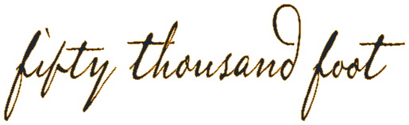
Fifty Thousand Foot Inc.
Cookie Policy
Version 1.0; June 2018

Contents
Cookies 1
What are cookies? 1
How do we use cookies? 1
How to control cookies 2

Document Revisions
Version # | Date | Description | Author
v1 | June 2018 | Initial version | Trent Poplar

Cookies
To make this site work properly, we place small data files called cookies on your device. This is similar to other social media and talent solution sites.

What are cookies?
A cookie is a small text file that a website saves on your computer or mobile device when you visit the site. It enables the website to remember your actions and preferences (such as login, language, font size and other display preferences) over a period of time, so you don’t have to keep re-entering them whenever you come back to the site or browse from one page to another.

How do we use cookies?
A number of our pages use cookies to remember:
- your display preferences, such as contrast colour settings or font size
- if you wish to remain logged in after leaving the site
- if you have agreed (or not) to our use of cookies on this site

Enabling these cookies is not strictly necessary for the website to work but it will provide you with a better browsing experience. You can delete or block these cookies, but if you do that some features of this site may not work as intended.
These cookies are not used for any purpose other than those described here, and the pattern data is fully under our control.

How to control cookies
You can control and/or delete cookies as you wish – for details, see aboutcookies.org. You can delete all cookies that are already on your computer and you can set most browsers to prevent them from being placed. If you do this, however, you may have to manually adjust some preferences every time you visit a site and some services and functionalities may not work.

